DevOps

1. Setting up the Infrastructure:

○ 3 Instances are supposed to be created in AWS.

○ These 3 Instances will be acting as the Machines where Jenkins and its Jobs will be running 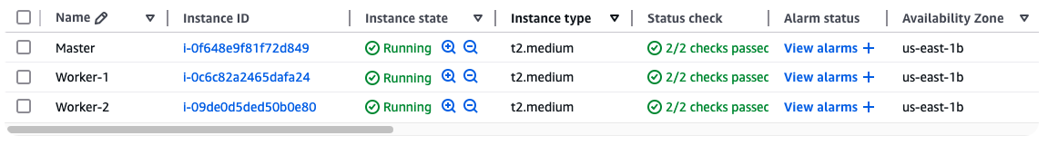

2. Setting Jenkins up:

○ Install Jenkins in one of the Machines along with Java.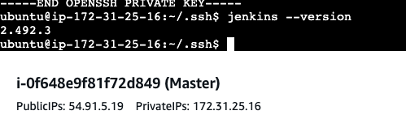

○ Set up the Jenkins Dashboard. 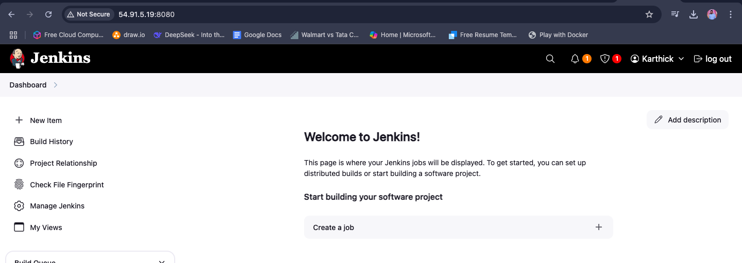

○ Setup both of the other machines as Jenkins Agents in the Dashboard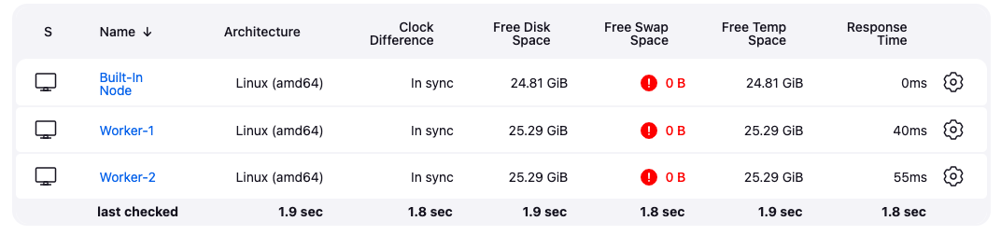

3. Setting up the GitHub repository provided below:

○ The GitHub repository that has to be set up is https://github.com/mdn/beginner-html-site-styled

○ Fork the repository on your end and use that forked repository for the rest of the Assignment. 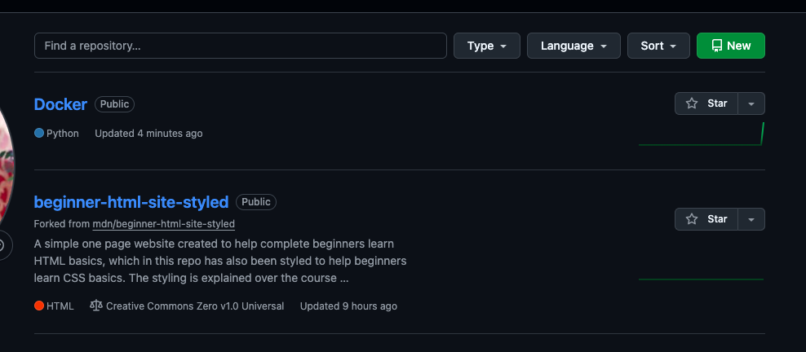

○ Create the Dockerfile to containerize the website that has been forked.

Machine :2 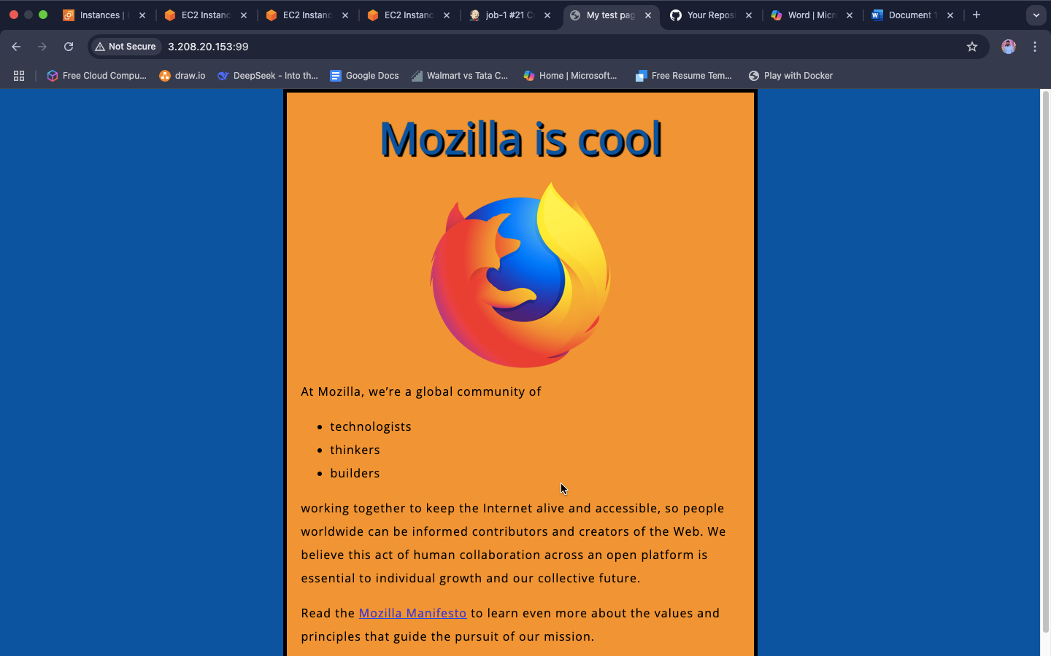

Machine 1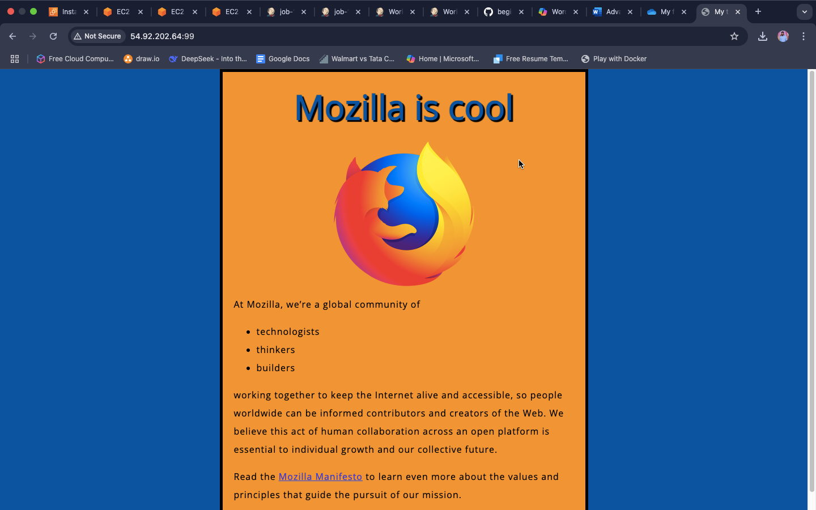

4. Create the Jenkins Job to perform the desired tasks as explained below:

○ The Job is supposed to create a container on port 99 everytime the Job is executed.

○ The Job will firstly create the image from the Dockerfile and then the container on port 99.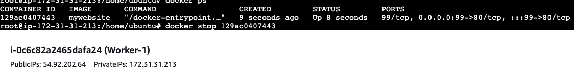 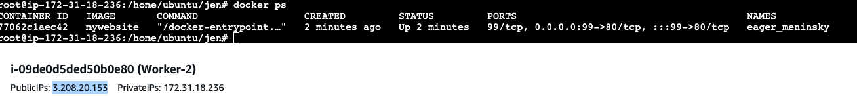

○ The Job should be triggered every time there is a change made in the GitHub repository